CS 255 Business Requirements Document Quinn

System Components and Design

Purpose
- The client is the company DriverPass, owned by Liam.
- The purpose of the DriverPass system is to help students pass their driving test by providing learning materials, practice tests, DMV rules and policies, as well as offering on-the-road driving lessons.

System Background
- DriverPass wants the system to help prepare students to pass their driving test.
- The problem of students failing their DMV test is what DriverPass wants to fix.
- DriverPass currently uses paper-based tracking.
- Components:
  - Offer three packages with varying lesson hours.
  - A scheduling and tracking system for two-hour driving lesson appointments.
  - Allow the secretary to schedule, modify, or cancel lessons.
  - Secure storage system for user information.
  - User accounts that can be specified for different roles.
  - Track 10 vehicles and 10 instructors.
  - Provide downloadable reports for the owner.

Objectives and Goals
- This system should be able to do the following:
  - Allow a secure login for all users: students, secretary, instructors, IT admin, and owner.
  - Allow students to purchase packages, access online materials, take practice tests, view scores, and schedule driving lessons.
  - Allow the secretary to view instructor and vehicle availability so they can schedule, modify, or cancel driving lessons for students.
  - Allow the instructor to add notes after each lesson and record lesson start and end times.
  - Allow the IT officer to reset passwords, block accounts, and maintain the system's functionality.
  - Allow the owner to view activity logs, download reports, and update what packages are offered.
  - Generate reports on scheduling, student progress, and instructor activity.
- This system needs to include these measurable tasks:
  - Successful login, checking for login attempts, failed logins, and locking accounts.
  - Accessing materials, checking for materials loading correctly and completion tracking.
  - Package tracking, checking time for package hour limits.
  - Scheduling, checking for appointments created, updated, or canceled successfully.
  - Driving lesson assignment, checking for vehicles and instructor availability.
  - Password resetting, checking for successful password change.
  - Report creation, checking for accurate data.

Requirements

Nonfunctional Requirements

Performance Requirements
- The system will be web-based and accessible on all modern web browsers.
- Content should be loaded within 3 seconds.
- The system should be able to handle multiple users at the same time with no performance changes.
- The system should be updated monthly to make sure policies and the system are up to date.

Platform Constraints
- The system should run on all modern web browsers.
- The system will be hosted on a cloud provider.
- The back end should have a database to store user profiles, packages, learning materials, vehicles, instructors, and reports.

Accuracy and Precision
- Each user will have their own profile.
- Login input should be case-sensitive.
- The system should inform the admin of a problem when someone gets locked out of their profile.
- The system should prevent double-booking instructors or vehicles for driving lessons.
- Package hours should be tracked precisely.

Adaptability
- Profiles need to be added, changed, or blocked without changing code.
- The system should adapt to platform updates by the IT admin.
- The IT admin needs access to user profiles with the ability to make changes.

Security
- A username and password are required for the user to log in.
- Use HTTPS/TLS to encrypt and authenticate data transmissions.
- If there is a “brute force” hacking attempt, the account should be locked, and the IT admin should be notified.
- The IT admin can reset passwords if the user forgets.
- The system should use a secure third-party payment processor.

Functional Requirements
- The system shall validate user credentials when logging in.
- The system shall allow students to purchase packages.
- The system shall allow students to access learning materials.
- The system shall track package hours and remove access when hours are met.
- The system shall allow students and the secretary to schedule, update, or cancel driving lessons.
- The system shall track vehicle availability and instructor availability.
- The system shall prevent double-booking of driving lessons.
- The system shall let the IT admin reset passwords and block accounts.
- The system shall store activity logs.
- The system shall update DMV rules and policies every month.
- The system shall let the owner generate reports.

User Interface
- The interface needs a secure login.
- The interface needs to specialize dashboards for each type of user.
- The different users for this interface are students, the secretary, the IT admin, and the owner.
- Students need to be able to purchase packages, access learning materials, take practice tests, view DMV rules, and schedule driving lessons through the interface.
- The secretary needs to be able to book, change, and cancel 2-hour appointment blocks while viewing the availability of instructors and vehicles through the interface.
- The instructors need to be able to log start and end times for lessons as well as log lesson notes.
- The IT admin needs to be able to reset passwords and manage user access through the interface.
- The owner needs to be able to run reports and update packages through the interface.

Assumptions
- Users have access to a web browser and Wi-Fi.
- Users have a basic understanding of how to use technology.
- Staff will be trained on how to use the system.
- DriverPass will have 10 vehicles and 10 instructors for appointments.

Limitations
- Time and budget limitations could affect features.
- A high volume of users all at once could slow down the system.
- The system relies on a cloud provider.
- The system relies on a third-party payment processor.
- The system is designed for 10 vehicles and 10 instructors.
- Weather or illness could affect appointments.
- Potential limits of compatibility with older technology.

Gantt Chart
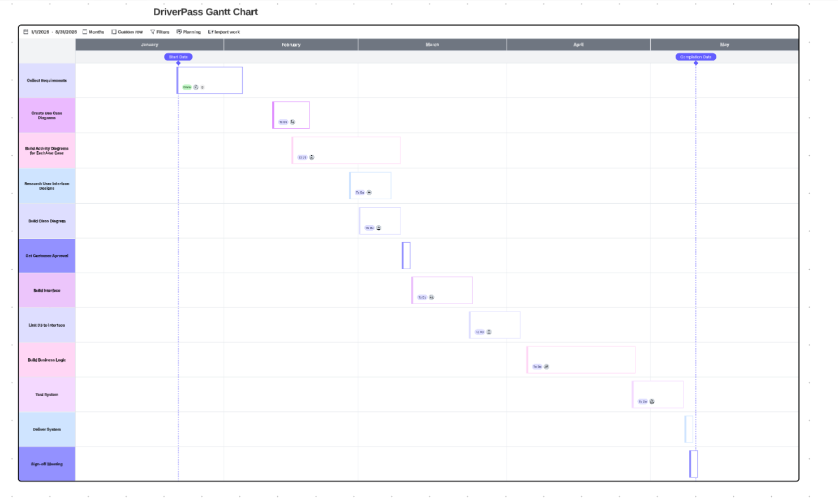

Resources

M, S. (2025, July 7). How to Secure Client and Server Communication. Digitraly. https://www.digitraly.com/how-to-secure-client-and-server-communication/

